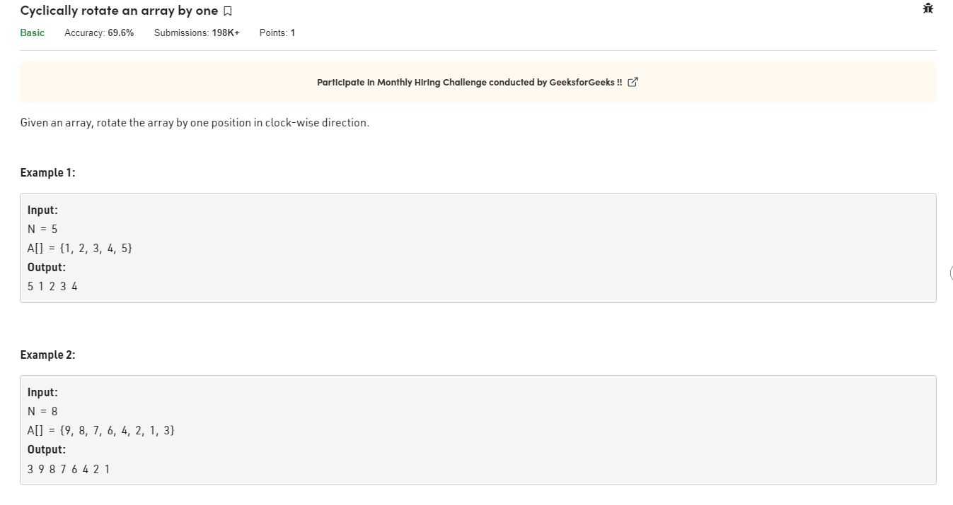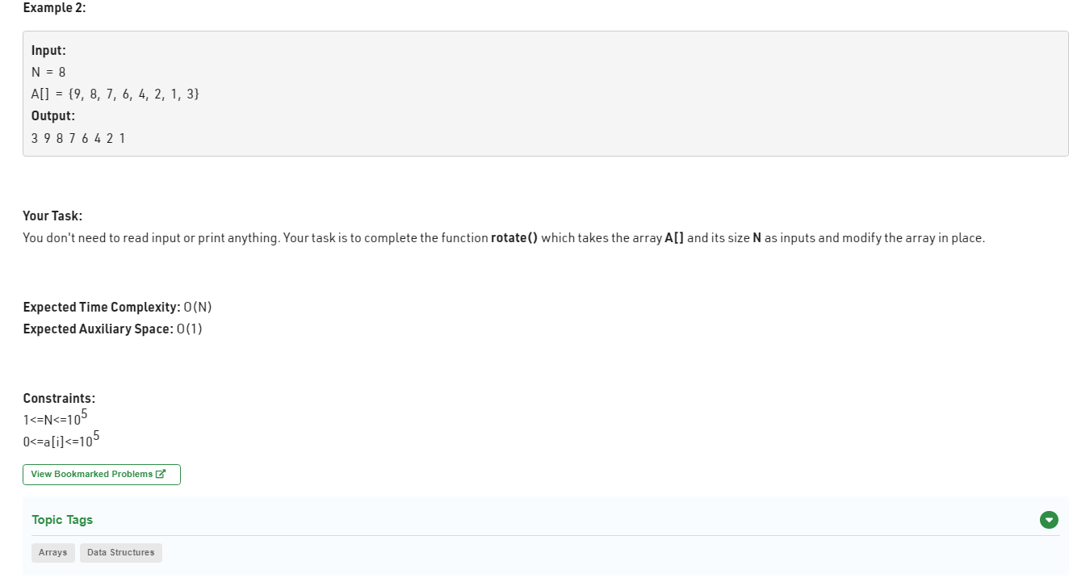

//User function Template for Java

class Compute {

public void rotate(int arr[], int n)

{

for(int i=0;i<n;i++){

int temp=0;

temp = arr[n-1];

arr[n-1] = arr[i];

arr[i] = temp;

}

}

}